**SL4J Logging exercises**

**Exercise 1: Logging Error Messages and Warning Levels**

**1. Added SLF4J and Logback dependencies to `pom.xml` file.**

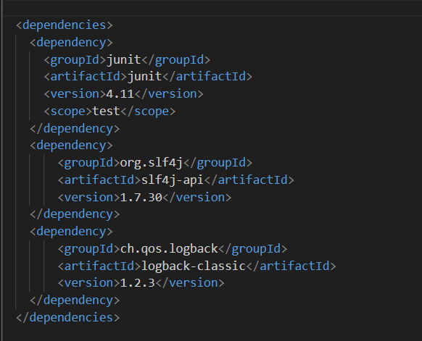

**2. Java class code that uses SLF4J for logging.**

|  |
| --- |
| LoggingExample.java  package com.example;  import org.slf4j.Logger;  import org.slf4j.LoggerFactory;  public class LoggingExample {      private static final Logger logger = LoggerFactory.getLogger(LoggingExample.class);      public static void main(String[] args) {          logger.error("This is an error message");          logger.warn("This is a warning message");      }  } |

**OUTPUT:**

